Date: 17/03/2022

Lab Session No.: 05

**Aim:**

Develop an android application that prompts the user to cast the poll

**Software’s /IDE Tools:**

Android Development Kit / Android Studio

**Application User interface design:**

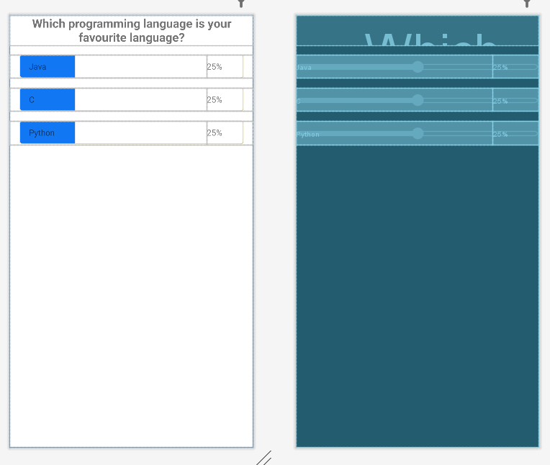

**Application Programming Interface:**

|  |  |  |  |
| --- | --- | --- | --- |
| **API / PACKAGES** | **CLASSES / INTERFACES** | **METHODS** | **DESCRIPTION** |
| import androidx.appcompat.app.AppCompatActivity; | AppCompatActivity | protected void onCreate(Bundle savedInstanceState) | onCreate(Bundle) is where you initialize your activity. When Activity is started and application is not loaded, then both onCreate() methods will be called. |
|  |  |
| import android.widget.EditText; | EditText | getText() | Determines the minimum type that getText() will return. If set, specifies that this TextView has a textual input method and should automatically capitalize what the user types. |

**Code/Implementation:**

// Develop an android application to demonstrate the Implicit and Explicit Intent.

// Project Name : ShareMyApp

/*

Lab Session No. : 05

Author : Tellakula Avinash

Date : 17/03/2022

Roll Number : 198W1A05C0

Description : Implementation of Constraint Layout

Softwares required :Android Studio

Topics Covered : Constraint Layout, TextView, EditText,

Button,Seekbar

*/

*MainAcitivity.java*

package com.avinash.pollstatus1;  
  
import androidx.appcompat.app.AppCompatActivity;  
  
import android.os.Bundle;  
import android.view.MotionEvent;  
import android.view.View;  
import android.widget.SeekBar;  
import android.widget.TextView;  
  
public class MainActivity extends AppCompatActivity {  
 SeekBar seekbar1, seekbar2, seekbar3;  
 TextView tvOption1, tvOption2, tvOption3;  
 TextView tvPercent1, tvPercent2, tvPercent3;  
 int counter1 = 1, counter2 = 1, counter3 = 1;  
 boolean flag1 = true, flag2 = true, flag3 = true;  
  
 @Override  
 protected void onCreate(Bundle savedInstanceState) {  
 super.onCreate(savedInstanceState);  
 setContentView(R.layout.activity_main);  
  
 seekbar1 = findViewById(R.id.seek_bar1);  
 seekbar2 = findViewById(R.id.seek_bar2);  
 seekbar3 = findViewById(R.id.seek_bar3);  
 tvOption1 = findViewById(R.id.tv_option1);  
 tvOption2 = findViewById(R.id.tv_option2);  
 tvOption3 = findViewById(R.id.tv_option3);  
 tvPercent1 = findViewById(R.id.tv_percent1);  
 tvPercent2 = findViewById(R.id.tv_percent2);  
 tvPercent3 = findViewById(R.id.tv_percent3);  
  
 seekbar1.setOnTouchListener(new View.OnTouchListener() {  
 @Override  
 public boolean onTouch(View view, MotionEvent motionEvent) {  
 return true;  
 }  
 });  
 seekbar2.setOnTouchListener(new View.OnTouchListener() {  
 @Override  
 public boolean onTouch(View view, MotionEvent motionEvent) {  
 return true;  
 }  
 });  
 seekbar3.setOnTouchListener(new View.OnTouchListener() {  
 @Override  
 public boolean onTouch(View view, MotionEvent motionEvent) {  
 return true;  
 }  
 });  
  
 tvOption1.setOnClickListener(new View.OnClickListener() {  
 @Override  
 public void onClick(View view) {  
 if (flag1) {  
 counter1=counter1+1;  
 counter2 = 1;  
 counter3 = 1;  
 flag1 = false;  
 flag2 = true;  
 flag3 = true;  
 calcpercent();  
  
 }  
 }  
 });  
 tvOption2.setOnClickListener(new View.OnClickListener() {  
 @Override  
 public void onClick(View view) {  
 if (flag2) {  
 counter1=1;  
 counter2++;  
 counter3 = 1;  
 flag1 = true;  
 flag2 = false;  
 flag3 = true;  
 calcpercent();  
  
 }  
 }  
 });  
 tvOption3.setOnClickListener(new View.OnClickListener() {  
 @Override  
 public void onClick(View view) {  
 if (flag3) {  
 counter1=1;  
 counter2 = 1;  
 counter3++;  
 flag1 = true;  
 flag2 = true;  
 flag3 = false;  
 calcpercent();  
  
 }  
 }  
 });  
  
  
 }  
  
 private void calcpercent() {  
 double total = counter1 + counter2 + counter3;  
 System.out.println(total);  
 double percent1 = (counter1 / total) * 100;  
 double percent2 = (counter2 / total) * 100;  
 double percent3 = (counter3 / total) * 100;  
  
 tvPercent1.setText(String.format("%.0f%%", percent1));  
 seekbar1.setProgress((int) percent1);  
 tvPercent2.setText(String.format("%.0f%%", percent2));  
 seekbar2.setProgress((int) percent2);  
 tvPercent3.setText(String.format("%.0f%%", percent3));  
 seekbar3.setProgress((int) percent3);  
 }  
}

*activity_main.xml*

*<?*xml version="1.0" encoding="utf-8"*?>*<androidx.constraintlayout.widget.ConstraintLayout xmlns:android="http://schemas.android.com/apk/res/android"  
 xmlns:app="http://schemas.android.com/apk/res-auto"  
 xmlns:tools="http://schemas.android.com/tools"  
 android:layout_width="match_parent"  
 android:layout_height="match_parent"  
 android:layout_gravity="center"  
 tools:context=".MainActivity">  
  
 <TextView  
 android:layout_width="match_parent"  
 android:layout_height="wrap_content"  
 android:id="@+id/tv_question"  
 android:text="Which programming language is your favourite language?"  
 android:textSize="20sp"  
 android:textStyle="bold"  
 android:textAlignment="center"  
 app:layout_constraintTop_toTopOf="parent"  
 app:layout_constraintEnd_toStartOf="parent"  
 tools:ignore="HardcodedText" />  
 <SeekBar  
 android:layout_width="match_parent"  
 android:layout_height="wrap_content"  
 android:id="@+id/seek_bar1"  
 android:max="100"  
 android:progress="25"  
 android:layout_marginTop="16dp"  
 android:thumb="@android:color/transparent"  
 android:progressDrawable="@drawable/progress_track"  
 app:layout_constraintTop_toBottomOf="@+id/tv_question"  
 app:layout_constraintStart_toStartOf="parent"  
 tools:ignore="MissingConstraints"  
 />  
  
 <TextView  
 android:layout_width="0dp"  
 android:layout_height="40dp"  
 android:id="@+id/tv_option1"  
 android:text="Java"  
 android:paddingStart="32dp"  
 android:paddingEnd="0dp"  
 android:layout_marginTop="16dp"  
 android:gravity="center_vertical"  
 app:layout_constraintTop_toBottomOf="@+id/tv_question"  
 app:layout_constraintStart_toStartOf="parent"  
 app:layout_constraintEnd_toStartOf="@+id/tv_percent1"  
 tools:ignore="HardcodedText" />  
 <TextView  
 android:layout_width="wrap_content"  
 android:layout_height="40dp"  
 android:id="@+id/tv_percent1"  
 android:text="25%"  
 android:paddingStart="0dp"  
 android:paddingEnd="52dp"  
 android:layout_marginTop="16dp"  
 android:gravity="center_vertical"  
 app:layout_constraintTop_toBottomOf="@+id/tv_question"  
 app:layout_constraintEnd_toEndOf="parent"  
 tools:ignore="HardcodedText" />  
 <SeekBar  
 android:layout_width="match_parent"  
 android:layout_height="wrap_content"  
 android:id="@+id/seek_bar2"  
 android:max="100"  
 android:progress="25"  
 android:layout_marginTop="16dp"  
 android:thumb="@android:color/transparent"  
 android:progressDrawable="@drawable/progress_track"  
 app:layout_constraintTop_toBottomOf="@+id/seek_bar1"  
 app:layout_constraintStart_toStartOf="parent"  
 tools:ignore="MissingConstraints"  
 />  
 <TextView  
 android:layout_width="0dp"  
 android:layout_height="40dp"  
 android:id="@+id/tv_option2"  
 android:text="C"  
 android:paddingStart="32dp"  
 android:paddingEnd="0dp"  
 android:layout_marginTop="16dp"  
 android:gravity="center_vertical"  
 app:layout_constraintTop_toBottomOf="@+id/seek_bar1"  
 app:layout_constraintStart_toStartOf="parent"  
 app:layout_constraintEnd_toStartOf="@+id/tv_percent2"  
 tools:ignore="HardcodedText" />  
 <TextView  
 android:layout_width="wrap_content"  
 android:layout_height="40dp"  
 android:id="@+id/tv_percent2"  
 android:text="25%"  
 android:paddingStart="0dp"  
 android:paddingEnd="52dp"  
 android:layout_marginTop="16dp"  
 android:gravity="center_vertical"  
 app:layout_constraintTop_toBottomOf="@+id/seek_bar1"  
 app:layout_constraintEnd_toEndOf="parent"  
 tools:ignore="HardcodedText" />  
 <SeekBar  
 android:layout_width="match_parent"  
 android:layout_height="wrap_content"  
 android:id="@+id/seek_bar3"  
 android:max="100"  
 android:progress="25"  
 android:layout_marginTop="16dp"  
 android:thumb="@android:color/transparent"  
 android:progressDrawable="@drawable/progress_track"  
 app:layout_constraintTop_toBottomOf="@+id/seek_bar2"  
 app:layout_constraintStart_toStartOf="parent"  
 tools:ignore="MissingConstraints"  
 />  
 <TextView  
 android:layout_width="0dp"  
 android:layout_height="40dp"  
 android:id="@+id/tv_option3"  
 android:text="Python"  
 android:paddingStart="32dp"  
 android:paddingEnd="0dp"  
 android:layout_marginTop="16dp"  
 android:gravity="center_vertical"  
 app:layout_constraintTop_toBottomOf="@+id/seek_bar2"  
 app:layout_constraintStart_toStartOf="parent"  
 app:layout_constraintEnd_toStartOf="@id/tv_percent3"  
 tools:ignore="HardcodedText" />  
 <TextView  
 android:layout_width="wrap_content"  
 android:layout_height="40dp"  
 android:id="@+id/tv_percent3"  
 android:text="25%"  
 android:paddingStart="0dp"  
 android:paddingEnd="52dp"  
 android:layout_marginTop="16dp"  
 android:gravity="center_vertical"  
 app:layout_constraintTop_toBottomOf="@+id/seek_bar2"  
 app:layout_constraintEnd_toEndOf="parent"  
 tools:ignore="HardcodedText" />  
</androidx.constraintlayout.widget.ConstraintLayout>

progress_track.xml:

*<?*xml version="1.0" encoding="utf-8"*?>*<layer-list xmlns:android="http://schemas.android.com/apk/res/android">  
 <item>  
 <shape android:shape="rectangle">  
 <solid android:color="@android:color/transparent"/>  
 <size android:height="40dp"/>  
 <corners android:radius="4dp"/>  
 <stroke android:color="#F3D304" android:width="1dp"/>  
  
 </shape>  
 </item>  
 <item>  
 <scale android:scaleWidth="100%">  
 <selector>  
 <item android:state_enabled="false" android:drawable="@android:color/transparent"/>  
 <item>  
 <shape android:shape="rectangle">  
 <solid android:color="#67F311"/>  
 <size android:height="40dp"/>  
 <corners android:bottomLeftRadius="4dp"  
 android:topLeftRadius="4dp"/>  
 <stroke android:color="#E0E0E0" android:width="1dp"/>  
 </shape>  
 </item>  
 </selector>  
 </scale>  
 </item>  
</layer-list>

**Output:**

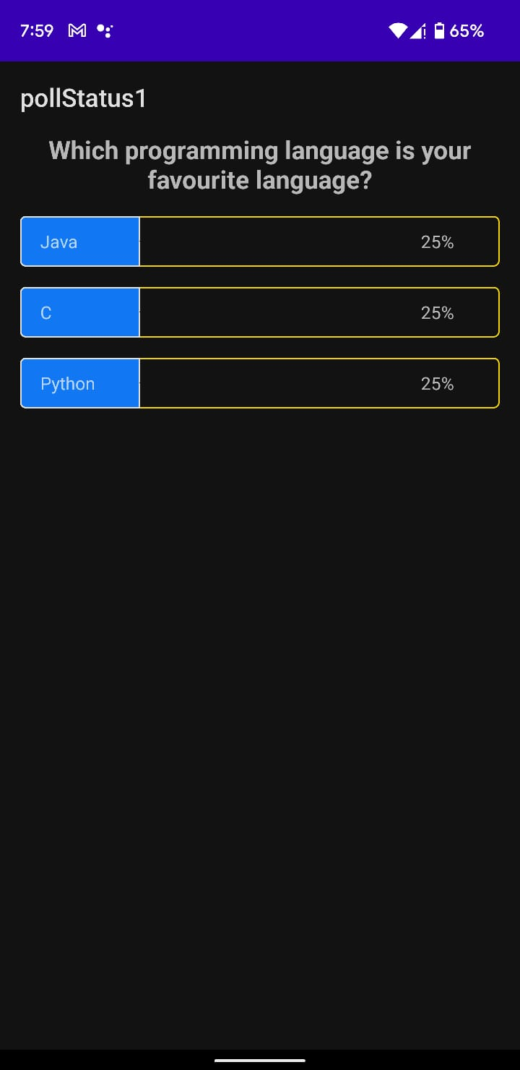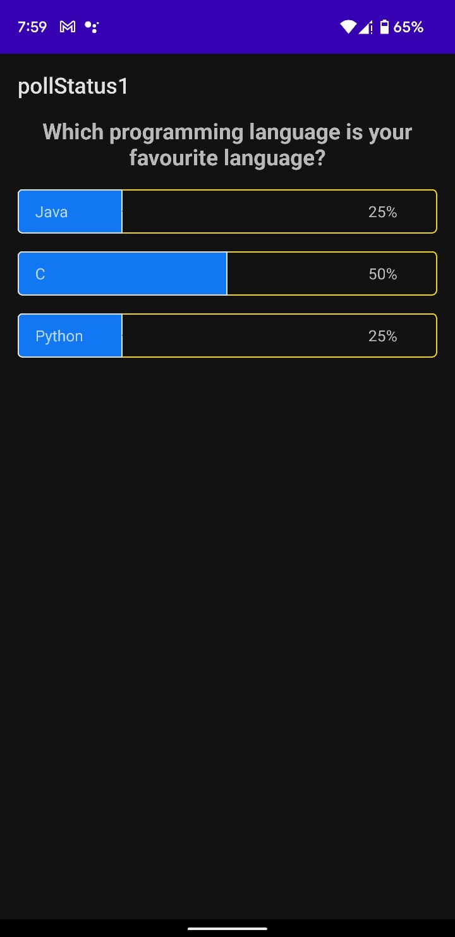

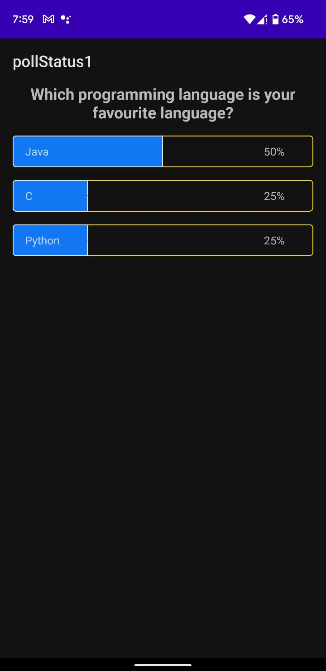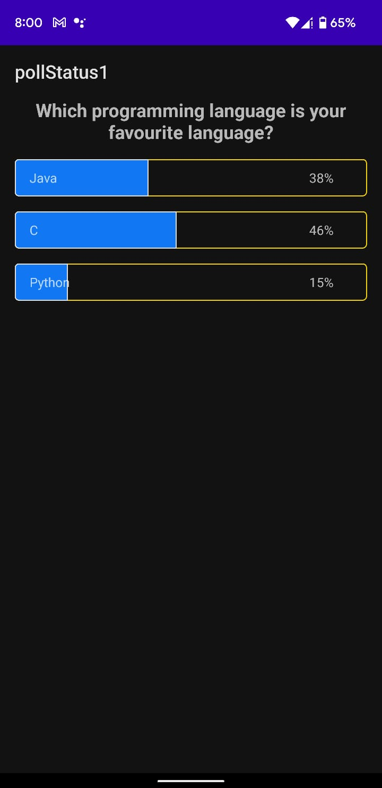

**Result:**

Developing an android application that prompts the user to cast the poll is executed Successfully.